

SUBMITTED BY: RIPANJOT KAUR
REGISTRATION NUMBER: 72410205
COURSE: BBA (BA)
SECTION: D
SUBJECT: DESIGN THINKING
TOPIC: EMPATHY MAP

SUBMITTED TO: MS. RASHI

Introduction
The Classical Empathy Map is a widely used design-thinking tool developed by Dave Gray (founder of XPLANE). It helps organizations, designers, marketers, and product developers better understand their customers or target audience. It is called ‘classical’ because it refers to the original 4-quadrant version of the empathy map, which has been foundational in customer-centric strategy building.
At its core, the empathy map is about visualizing what a customer thinks, feels, says, and does in a given situation. Unlike market research data that only focuses on demographics or behaviour, the empathy map emphasizes the psychological and emotional dimensions of users. By doing so, it helps bridge the gap between the product/service and real human needs.

Structure of the Classical Empathy Map

The classical empathy map is usually represented as a canvas divided into four quadrants surrounding a sketch or symbol of the ‘user/customer.’ Each quadrant answers a specific question about the user’s experiences:

- Says – What does the user explicitly say in interviews, conversations, or feedback?
- Thinks – What occupies the user’s thoughts and concerns, even if they don’t verbalize it?
- Does – What actions and behaviours does the user perform in real situations?
- Feels – What emotions drive or hinder the user in the given context?

This four-part model captures both external expressions (says/does) and internal states (thinks/feels), creating a holistic view of the customer.
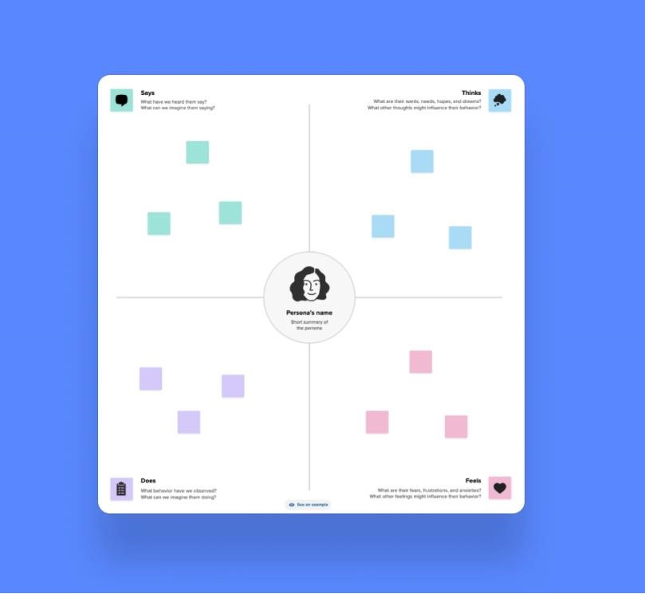

Components of the Classical Empathy Map
a) Says
- This quadrant records direct quotes or statements from the user.
- Example: A customer might say, “This app is too complicated to set up,” or “I love how fast the delivery is.”
- Data sources: interviews, surveys, customer support interactions, testimonials.
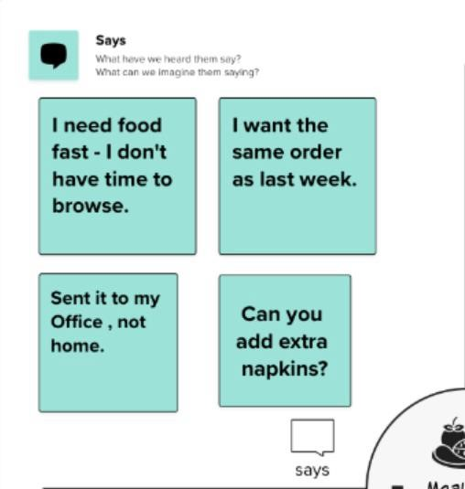
- b) Thinks
- Focuses on the unspoken thoughts, beliefs, and assumptions a customer has.
- These are harder to capture but can be inferred from patterns in behaviour and context.
- Example: A user may think, “I don’t trust online payment fully,” even if they don’t say it aloud.
- Data sources: behavioural studies, observation, contextual inquiry.
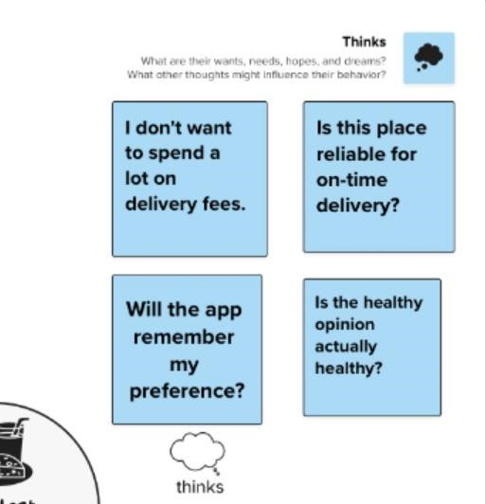

- Does
  - Reflects the actual actions and behaviours of the user in real life.
  - Example: Browsing a website multiple times before making a purchase, abandoning carts, or checking reviews before buying.
  - Data sources: analytics, user journey mapping, ethnographic studies.
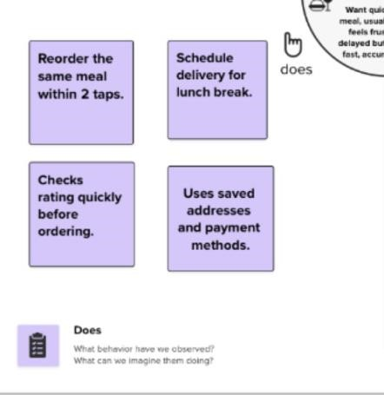

- Feels
  - Focuses on the emotional state of the user—both positive and negative.
  - Example: A user might feel frustrated with a slow app, anxious about delivery delays, or delighted when customer service is responsive.
  - Data sources: tone of voice in conversations, body language in observations, emotional response studies.

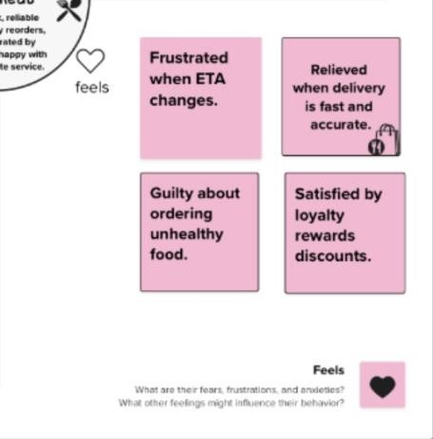

Purpose of the Classical Empathy Map
- User-Centric Understanding: Moves beyond demographics to understand psychological and emotional drivers.
- Identify Pain Points: Reveals frustrations, barriers, and unmet needs.
- Highlight Motivations: Shows what excites and motivates users.
- Improve Products/Services: Guides teams to align solutions with real user needs.
- Enhance Communication: Provides a shared visualization that teams can collaboratively build upon.

Applications of the Classical Empathy Map
- Product Design: Helps UX/UI designers create intuitive interfaces.
- Marketing: Enables marketers to craft messages that resonate emotionally.
- Customer Experience (CX): Improves service design and customer journey mapping.
- Innovation Workshops: Used in brainstorming sessions to generate user-centered ideas.
- Business Strategy: Aligns leadership decisions with customer expectations.

Example
Suppose you are mapping the experience of an online food delivery app user:
- Says: “The app is easy to use, but delivery takes too long.”
- Thinks: “Maybe I should try another app with better ratings.”
- Does: Frequently checks delivery time, compares prices with competitors, leaves reviews.
- Feels: Excited when food is discounted, frustrated when orders are late.
This map can guide the business to reduce delivery time, improve tracking features, and launch loyalty rewards, directly addressing user needs.
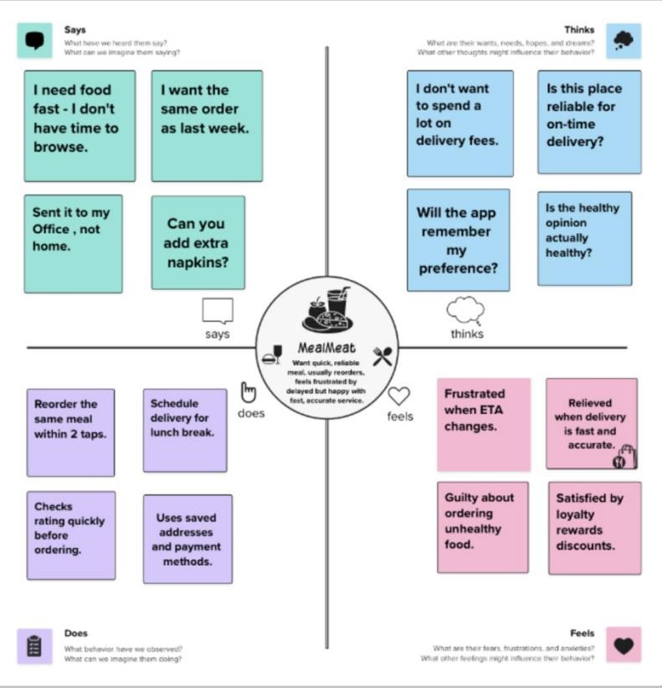

Conclusion
Classical Empathy Map is a foundational design-thinking tool that transforms abstract customer data into human-centered insights. By analysing what users say, think, do, and feel, organizations can design solutions that are more relevant, emotionally resonant, and impactful. Though simple, it is one of the most powerful frameworks to build empathy-driven strategies in business, product design, and marketing.

Empathy Map – Student Online Learning Experience (Ripanjot Kaur, BBA – BA)
The empathy map highlights the challenges, emotions, and behaviours of a student experiencing online learning. It helps understand how the student interacts with the digital learning environment and what factors affect her performance and motivation.

- SAYS
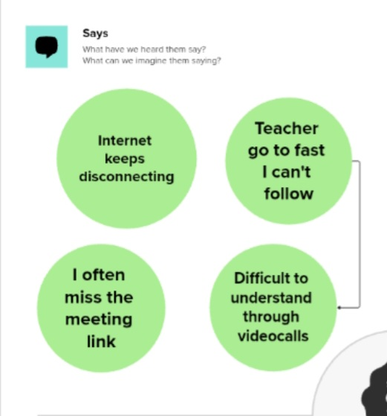
Explanation: These statements reflect technical difficulties, fast teaching pace, and confusion faced during online classes.

- THINKS
Explanation: Shows anxiety, fear of failure, and uncertainty about her academic progress.
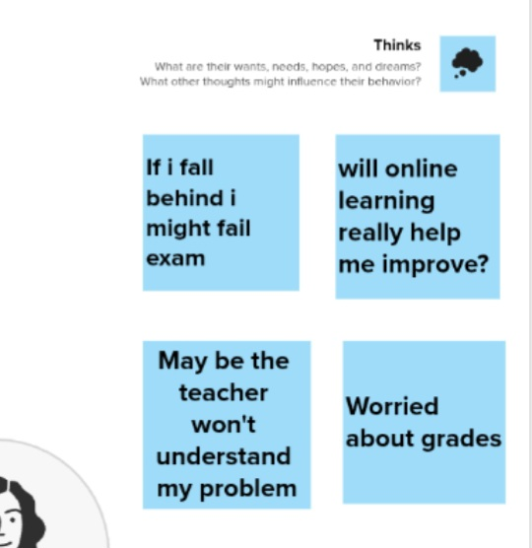

- DOES
Explanation: Indicates low engagement and distraction while attempting to cope with studies.
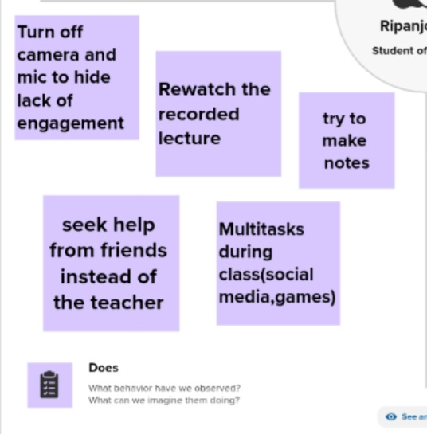

- FEELS
Explanation: Emotional pressure, disappointment, and isolation affect her learning experience. The student feels stressed and anxious because the class moves quickly and technical issues disturb her focus. She also feels isolated at times, missing the comfort and interaction of a physical classroom.

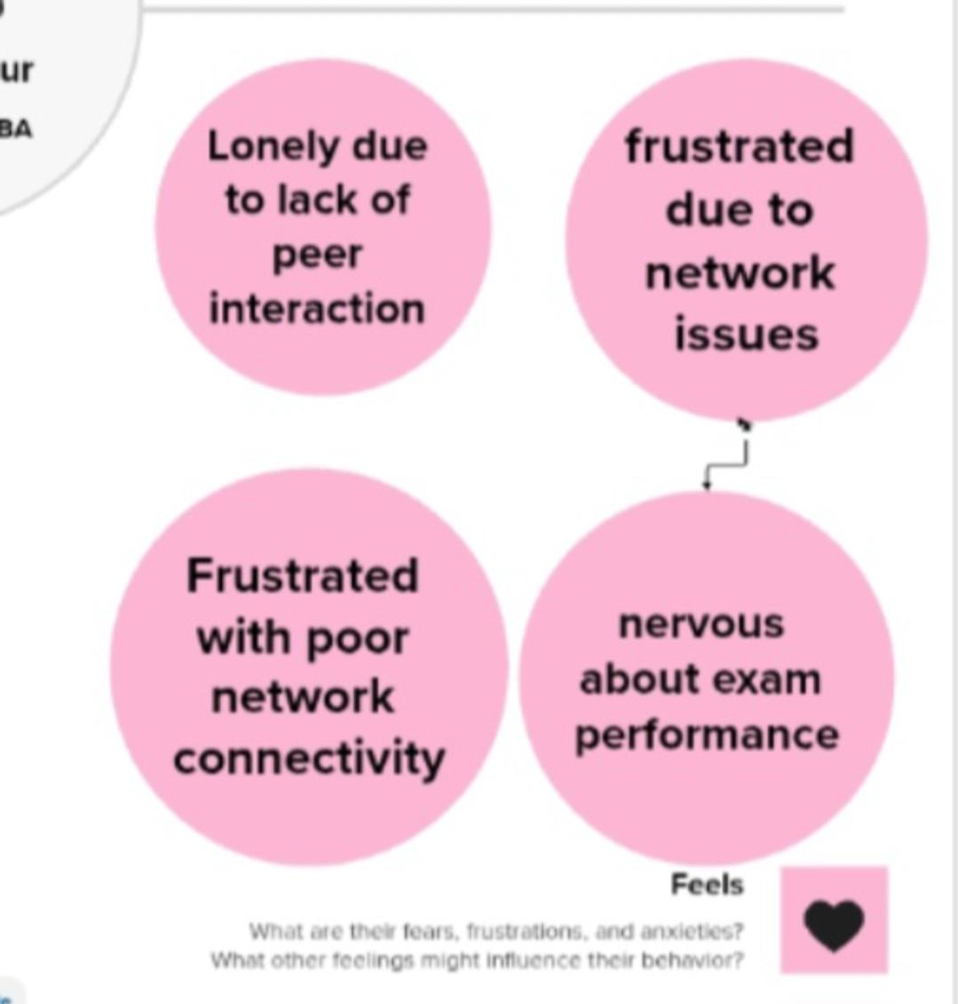

Example
An empathy map helps us understand a student’s feelings, thoughts, and behaviour during online classes. For example, in an online classroom, a student says she can’t hear the teacher properly, thinks she might fall behind because the pace is too fast, does activities like taking quick screenshots or rewinding the lecture, and feels confused or stressed due to network issues. This map helps teachers improve the online learning experience by addressing the student’s real challenges.
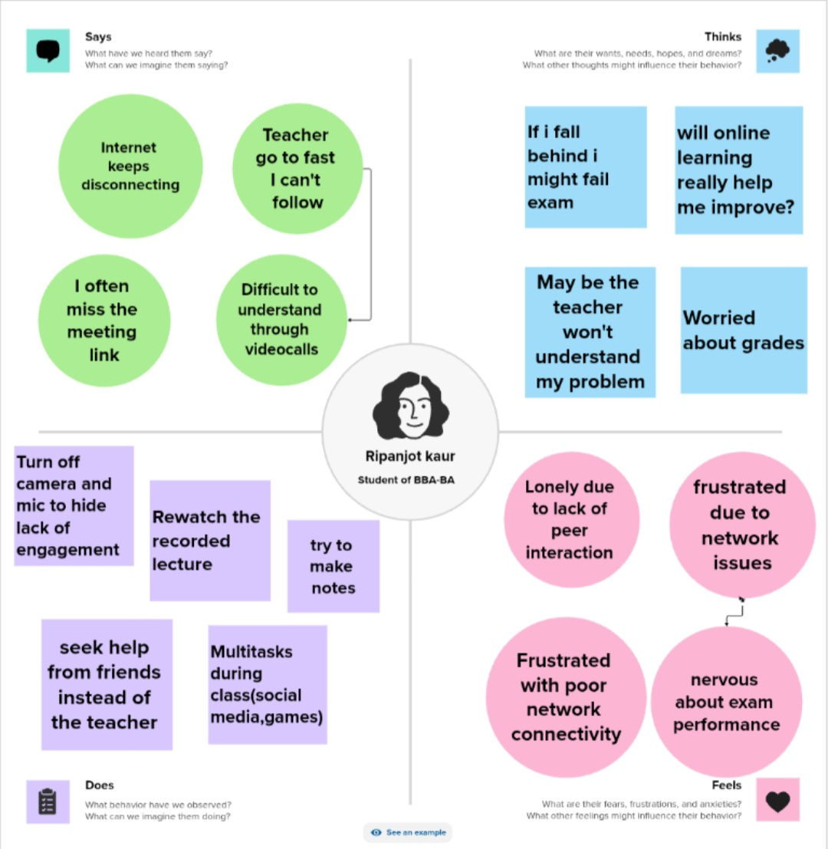

Conclusion:
The empathy map highlights the technical and emotional challenges the student faces in online learning. Understanding these issues can help improve teaching support and engagement . The empathy map shows that the student faces emotional, technical, and learning challenges in an online classroom. Understanding these insights helps teachers design smoother, more supportive online learning experiences.

